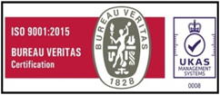

M S S C E T

Date: 25-Jul-2022

**BONAFIDE CERTIFICATE**

This is to certify that, Mr/Miss. **Aditya Anil Desai (USN: 2KL19EC002)** is a bonafide student of this college studying in V/VI Bachelor of Engineering (ECE Branch) during the year 2021-22.

His/her date of birth as per records is: 2022-07-28

**PRINCIPAL**